A Review on

"Plant Leaf Disease Detection and Classification Using AI and Computer Vision Techniques"

Rati Goel1, Shikhar Sharma2, Ujjawal Singh3, Piyush Pandey4, Yash Srivastava5

[rati.python@gmail.com](mailto:rati.python@gmail.com), [2130154066@ipec.org.in](mailto:2130154066@ipec.org.in), [2130154074@ipec.org.in](mailto:2130154074@ipec.org.in), [2130154048@ipec.org.in](mailto:2130154048@ipec.org.in), [2130154081@ipec.org.in](mailto:2130154081@ipec.org.in)

Inderprastha Engineering College Ghaziabad

**Abstract**

Agriculture is essential for many nations' incomes. Diseases in plants caused by pathogens such as viruses, fungi, and bacteria cause global financial losses in agriculture. Effective disease management ensures crop quality and yield. Disease symptoms are often visible on various plant parts, with leaves being the most affected. Researchers have utilized computer vision, deep learning, few-shot learning, and soft computing techniques to automatically identify plant diseases using leaf images. These technologies help farmers act promptly to protect crops. By automating disease detection, these methods resolve limitations of traditional methods, enhancing both research speed and technology effectiveness. Additionally, molecular techniques have been developed to mitigate pathogenic threats. This review examines the use of machine learning, deep learning, and few-shot learning for automated plant disease detection, reviews diagnostic techniques and future advancements. The integration of these advanced techniques into agricultural practices not only aids in timely disease detection but also supports sustainable farming by reducing reliance on chemical treatments. By leveraging machine learning and molecular diagnostics, farmers can implement targeted interventions, minimizing environmental impact and improving resource efficiency. These innovations are vital in addressing the growing challenges of food security and climate change, ensuring the resilience of agricultural systems worldwide.

Keywords: Deep learning, diagnosis, image processing, machine learning, and plant disease.

1. Introduction

The United Nations' Food and Agriculture Organization has reported a consistent increase in global hunger since 2015. Current estimates suggest that approximately 680 million people are undernourished, accounting for less than 9% of the global population. This represents an annual increase of 10 million people and a rise of around 120 million over the last decade. Moreover, over 85% of the global population depends on agriculture for sustenance, underscoring the critical need for efficient farming mechanisms. Plants also play a vital role in maintaining environmental balance by producing oxygen through photosynthesis. However, plant diseases, particularly those affecting leaves, can severely impact plant health and disrupt food production. A historical example is the 1845 Irish Potato Famine, which caused 1.2 million deaths due to crop failure [1]. Laboratory techniques such as immunosorbent enzyme assays, isothermal amplification, and polymerase chain reaction (PCR) are commonly employed to detect plant diseases.

Early detection, effective management, and prevention of plant diseases are essential. However, diagnosing diseases in large agricultural fields is challenging, requiring skilled personnel and visual inspection of plant leaves [2]. Farmers typically rely on their experience to identify symptoms, a process that is time-intensive, laborious, and demands specialized skills. Automated disease detection systems aim to assist non-experts, including non-pathologists and non-botanists.

This review explores automated techniques utilizing image processing, machine learning, deep learning, and few-shot learning for plant disease detection. Traditional machine learning approaches often lack robustness and are confined to controlled laboratory settings [3]. In contrast, deep learning has recently demonstrated remarkable success in classifying plant disease images. However, deep learning methods require extensive datasets, with images meticulously annotated by pathologists and botanists. These processes are resource-intensive and costly. Few-shot learning (FSL) offers an alternative by enabling models to learn from limited labeled datasets [4], where the number of samples depends on the experiment's objectives and complexity.

Various pathogens contribute to plant diseases and can be identified using molecular techniques such as DNA analysis, PCR, MPG (Modified Panchayat Mixture), ELISA (Enzyme-Linked Immunosorbent Assay), FISH (Fluorescence in Situ Hybridization), and IF (Immunofluorescence) methods. This review paper provides a comparative analysis of machine learning, deep learning, and few-shot learning in plant disease detection. It also examines segmentation, feature extraction, and classification techniques alongside molecular diagnostic tools [5].

Objective

The objective of the project "Plant Leaf Disease Detection and Classification Using AI and Computer Vision Techniques" is to develop an intelligent system capable of identifying and classifying plant leaf diseases accurately and efficiently. By leveraging advanced AI algorithms and computer vision, the system aims to assist farmers and agricultural professionals in detecting diseases at an early stage, reducing crop losses and improving productivity.

1. Phytopathology

Phytopathology refers to the study of plant pathogens, the diseases they cause, their mechanisms, and methods to control and mitigate their impact on plants. It serves as a comprehensive framework for understanding and managing a plant's life cycle. Derived from Greek, "Phytopathology" combines "Phyto" (plant), "Patho" (disease), and "Logo" (knowledge) [6]. Its core objectives include investigating the origins and causes of plant diseases, whether biotic or abiotic (etiology), understanding the mechanisms behind disease development (pathogenesis), examining interactions between plant pathogens and diseases (epidemiology), and developing strategies to reduce damage and manage losses, as depicted in Fig. 1.

Pathogenesis

Control and Management

Phytopathology Objectives

Etiology

Epidemiology

Fig 1. Phytopathology objectives.

Phytopathology is a specialized subfield within agricultural science that integrates foundational knowledge from diverse disciplines such as microbiology, physiology, nematology, virology, anatomy, bacteriology, mycology, genetic engineering, botany, meteorology, climatology, and molecular biology, as illustrated in Fig. 2.

2.1 Plant disease: types and symptoms

Abnormalities in the behavior or physiology of plants lead to diseases, which can be caused by biotic or abiotic agents, as shown in Fig.2 [16]. Biotic diseases result from infectious agents, while abiotic diseases are caused by non-infectious factors. Abiotic diseases are generally less hazardous and non-transmissible, making them easier to prevent. This manuscript focuses on biotic diseases.

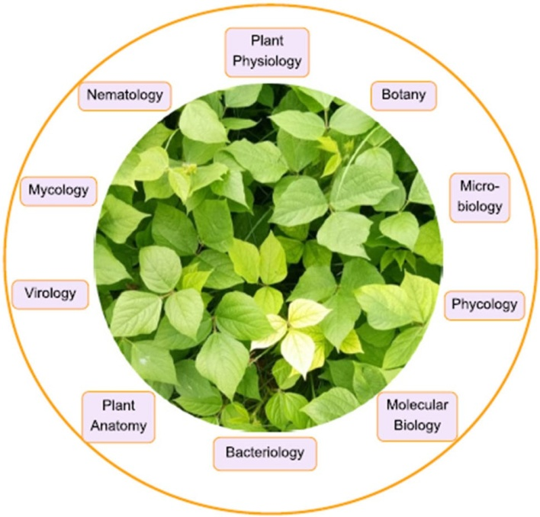

Fig 2. Subdomains of phytopathology

* Bacterial Diseases: Bacterial infections in plants typically begin as water-soaked lesions that develop into small green blemishes. Over time, these lesions expand and dry into dead spots, as illustrated in Fig. 4. For instance, foliage may display water-soaked black blemishes, brown leaf spots, or yellow halos of uniform size. Under dry conditions, the blemishes often appear dappled. Bacterial wilt, a common issue in brinjal crops, causes the entire plant to collapse [7].
* Viral Diseases: Viral infections in plants are among the most challenging to diagnose, as they may exhibit no visible symptoms or mimic signs of herbicide damage or nutrient deficiencies [7]. Commonly observed viral diseases include those transmitted by beetles, leafhoppers, aphids, and whiteflies, such as mosaic viruses, which manifest as green or yellow streaks on foliage, as shown in Fig. 4.
* Fungal Diseases: Fungal infections affect various parts of plants, including stems, leaves, seeds, and roots. Examples include sclerotium wilt, stem rust, blight, ergot, and carnal bunt. Late blight caused by *Phytophthora* fungus initially appears as gray-green waterlogged blemishes on older leaves, as shown in Fig. 3. Over time, these lesions darken, and white fungal growth may appear due to fluctuating wet and dry conditions [8]. Early blight caused by *Alternaria* fungus produces small brown blemishes with a characteristic concentric ring pattern, as shown in Fig. 3. Rust fungi form spots on mature leaves that turn black over time, as illustrated in Fig. 4.

The described symptoms are distinct but limited compared to the wide range of plant diseases. Similar symptoms may arise from both infectious and non-infectious causes, as summarized in Table 1.

Table 1 Distinct disease in different plants.

|  |  |  |  |  |
| --- | --- | --- | --- | --- |
| Author | Plant Name | Bacterial Disease | Viral Disease | Fungal Disease |
| Kianat et al. 2021 [9]  Agarwal et al. 2021 [10] | Cucumber | Brown Blemnish, Angular Blemnish, Target Blemnish | Mosaic, Yellow Blemnish | Black Blemish, Gray Mold |
| Shrivastava et al. 2019 [11]  Chen et al. 2021 [12] | Rice | Streak, Blight | Black Dwarfed Streaked | Smut False |
| Sun et al. 2021 [13] | Maize | Streak, Stalk | Crimson, Dwarf | Rust |
| Abbas et al. 2021 [14] | Tomato | Canker | Curl leaf yellow | Late/Early Blight |

Accurate diagnosis of plant diseases is a challenging task, as it requires distinguishing between pathogens based on specific symptoms. The effectiveness of artificial intelligence (AI) techniques in disease detection largely depends on feature extraction and classification [15]. These extracted features help identify disease symptoms and improve classification accuracy. Table 2 highlights examples of typical plant diseases and their associated symptoms, aiding researchers in selecting accurate features for high-performance disease detection.

Table 2. Distinct plants, their disease and responsible pathogen

|  |  |  |  |
| --- | --- | --- | --- |
| Plants | Diseases | Pathogens | Symptoms |
| Apple | Scab  Rot  Rust | PomiSpilocal  MalorumSphaeropsis  Sporangium | Brown-Gray on leaf  Dark Brown on leaf  Yellow pale on leaf |
| Cherry | Mildew | Clandestina | Gray powder on leaf |
| Corn | Gray Spot  Rust  Light blight | Cercospora  Sorghipuccinia  Tutcicasetosphaeria | Rectangle lesions  Red pustules on leaf  Elliptical lesions |
| Grape | Rot  Measles  Isariopsis blight | Bidwelliiguignardia  Aleophilum  Angulata brachypus | Red borders on leaf  Necrotic stripping  Coalesce lesions |
| Peach | Spot | Arboricola Xanthomonas | Clustered lesions |
| Potato | Early blight  Late blight | Solani Alternaria  Infestans phytophthora | Brown lesion  Dark greeb spot |
| Tomato | Septoria spot  Mosaic | Lycopersici  Mosaic virus | Foliage  Mottle green leaf |
| Orange | Green Citrus | Bacteria Motile | Precipitate Demolition |
| Strawberry | Scorch Fungus | Diplocarpon | Brown edges |
| Squash | Mildew | Xanthiipodosphaers | White powder |

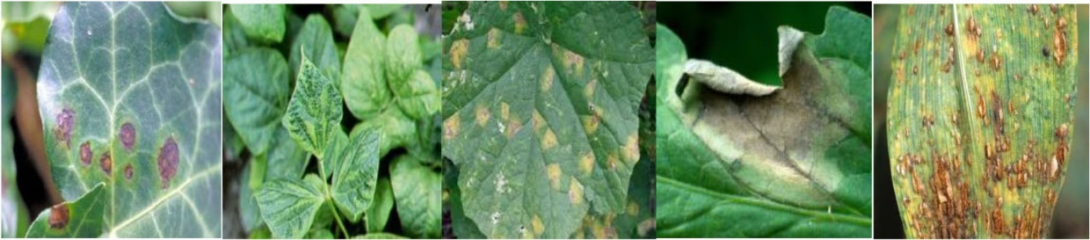

Fig. 3 (a) Bacterial blemish (b) Viral Mosaic (c) Late Blight  (d) Early Blight (e) Rust.

2.2 Plant disease detection system

Artificial intelligence (AI) techniques play a crucial role in enhancing agricultural productivity by enabling effective plant disease monitoring. Numerous studies have been conducted in this area [16], with some focusing on specific methods and others on individual diseases. However, a comprehensive review of plant disease detection, classification, and diagnostic techniques remains unavailable.

This review aims to bridge that gap by exploring various approaches employed by researchers, including machine learning (ML), deep learning (DL), few-shot learning (FSL), and soft computing techniques integrated with image processing for analyzing RGB and hyperspectral images. Additionally, molecular techniques are discussed, which have been developed to prevent and mitigate pathogenic threats effectively.

MACHINE LEARNING:

The process of detecting plant diseases using machine learning and image processing follows a series of sequential steps: **Image Acquisition, Image Preprocessing, Image Segmentation, Feature Extraction and Selection,** and **Classification** [17]. These steps are detailed below, along with key approaches proposed in the literature.

1. Image Acquisition:

This is the initial step in any machine learning system, involving capturing images or retrieving them from repositories. The quality of these images significantly impacts the system’s disease detection accuracy, [18]. Captured images may contain undesirable elements like background noise or shadows, which need to be removed for better analysis. In addition to standard RGB images, specialized cameras are used to capture hyperspectral, thermal, and fluorescent images. Consequently, the performance of the system relies heavily on the quality of images obtained during this stage. Table 3 summarizes datasets used in plant disease detection.

Table 3. Details of the dataset available used by various researchers.

|  |  |  |
| --- | --- | --- |
|  | Dataset Name | Authors |
| Open accessible dataset | APS Image dataset  Plant village image dataset  Computers & optics in food inspection (Cofi) laboratory image dataset  Digipathos Images (PDDB)  IRRI dataset  INIBAP Leaf dataset | Arnab Barbedo et. al. 2019 [18]  Bashir et. al. 2019 [19] |
| Self-created dataset | RoCoLe | Parraga Alava et. al. 2019 [20] |
| Multiple crop dataset | Citrus Dataset  Grape Fruit Grove | Masazhar& Kamal et. al. 2018 [21] |

1. Image Preprocessing: Image preprocessing is crucial to enhance image quality by eliminating distortions, turbulence, or shadows, especially in datasets captured in uncontrolled environments [22]. This step improves system accuracy and reduces processing time through operations such as cropping, resizing, and background removal. Common preprocessing techniques include image enhancement, noise removal, and augmentation methods like noise injection, flipping, gamma correction, scaling, rotation, shifting, zooming, and brightness/contrast adjustments.

Table 4. Details of techniques used by various researchers.

|  |  |  |
| --- | --- | --- |
|  | Technique Used | Authors |
| Color Space Conversion | Enhancement  Filtering,  Background reduction RGB, HSV, HSI, YIQ, L*a*b, grayscale | Kaur et al. 2018 [22], |
| Image Enhancement Technique | Denoising Using mean and median filtering  Illumination variation using histogram equalisation | Goncharov et. al. 2019 [23] |
| Thresholding techniques | Adaptative Thresholding, Entropy, classification of diseases and pests | M. Francisco et al. 2023 [24] |
| Clustering | k-means | Kaur et al. 2018b [22],  Bashir et al. 2019 [19] |
| Feature Descriptor | GLCM, Wavelet Transform, Haralick feature, Gabor Transform, Local Binary Patterns, SURF | Bhagat & Kumar 2023 [25] |
| Texture Feature | GLCM Features | Deshapande et al. 2019 [26], |
| Color feature | Color co-occurrence matrix | Chouhan et al. 2019 [27] |
| Feature Descriptor | discrete wavelet transforms and SVM | S. M. Kiran et al. 2021 [28] |

1. Image Segmentation: Image segmentation isolates the region of interest (e.g., infected areas) from the rest of the image. This step simplifies analysis by clearly separating affected and unaffected areas. Segmentation methods are broadly categorized into:

* Conventional Techniques: Thresholding, region growing, and edge detection.
* Computational Techniques: Fuzzy logic, genetic algorithms, and neural networks.

Computational methods generally outperform conventional ones. The segmentation process is essential for accurate feature extraction. Table 5 highlights segmentation techniques used by researchers.

1. Feature Extraction: Feature extraction is essential for distinguishing different parts of an image. Extracted features, such as color, texture, and shape, are critical for disease classification. The accuracy of plant disease detection systems heavily depends on effective feature extraction techniques [27]. To prevent overfitting and reduce computational costs, feature selection methods are employed to identify the most relevant features. Table 6 provides a summary of feature extraction techniques, while Fig. 4 illustrates trends in feature extraction research over the past 12 years.

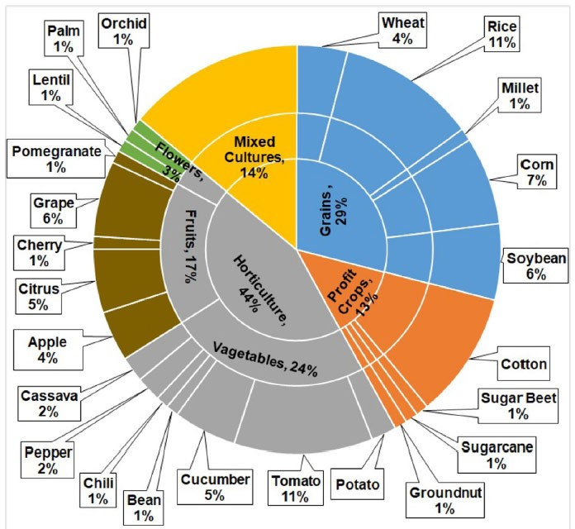

Fig 4. Different feature extraction techniques for distinct crops during last 12 years

1. Classification: Classification is the final and most critical stage in machine learning systems. The effectiveness of this step depends on the preceding stages (acquisition, preprocessing, and feature extraction/selection). In plant disease detection, this step involves training a dataset to classify test images as healthy or defective based on disease symptoms. Machine learning (ML) techniques are broadly categorized as:

Supervised Learning: Uses labeled data for training.

* Unsupervised Learning: Uses unlabeled data for training.
* Semi-Supervised Learning: Combines labeled and unlabelled data.

Additionally, vegetation index and fuzzy logic-based techniques are occasionally employed. Table 5 provides a comparative analysis of their performance in plant disease detection systems.

Table 5 Details of classification technique used by various researchers

|  |  |  |  |  |  |
| --- | --- | --- | --- | --- | --- |
|  | Authors | Dataset | Feature Extraction | Classifier | Accuracy (%) |
| Rice | Joshi & Jadhav 2017 [28]  Zhang et al. 2018a [29]  Bashir et al. 2019 [19]  Shrivastava & Pradhan 2021 [31]  Rath & Meher 2019 [32] | Agriculture Research(115)  60  -  APS (440)  Real FieldImages  Real Field Images | Color & Shape  Haar & SIFT  Color  SIFT  -  - | MD & k-NN  Vegetation Index  SVM  SVM  Radíal Basis NN | 88.15  63  94.16  94.65  95.00 |
| Wheat & Corn | Azadbakht et al. 2019 [33]  Kusumo et al. 2019 [34]  Deshapande et al. 2019 [26] | Academy(744)  Hyperspectral data  Plant Village(3823)  Agriculture University Dharwad (200) | Index based  SIFT, SURF  First Order histogram & GLCM | Regression  SVM, DT, RF, NaïveBayes  k-NN, SVM | 95.00  87.00  88.00 |
| Soyabean | Pires et al. 2016 [38]  Kaur et al. 2018b [19] | Federal (1200)  Plant Village (4775) | SIFT, SURF, HOG  Color, Texture, Shape | SVM  SVM | 96.25  84.00 |
| Millet | Caulibaly et al.2019 [35] | Self (124) | Transfer Learning | VGG16 | 89.00 |
| Sugar beet | Hallau et al. 2017 [36] | Self (1400) | Texture | SVM | 82.00 |
| Cane | Pujari et al. 2016 [37] | Self (9912) | RGB Color | SVM & EBΡΝΝ | 92.00 |
| Mix | Sladojevic et al. 2016 [39]  Ferentinos 2018 [25] | Internet (33469)  Plant Village & Self (87848) | -  TransferLearning | CNN  Alexnet, VGG | 95.80  99.53 |
| Apple | Jolly & Ramam 2016 [40] | Self (320) | Haarlick& LBP | SVM | 96.00 |
| Citrus | Sharif et al. 2018 [41] | Image Gallery dataset | Color, Texture, Geometrical | Multiclass SVM | 95.80 |
| Cherry | Sengar et. al. 2018 [42] | Plant Village | Lesion Area | - | 99.00 |
| Grape | Javidam et al. 2023 [43] | Self | GLCM | Inception V3  SVM | 98.97 |
| Cucumber | Zhang et al. 2017 [44] | Self | PHOG | SVM | 91.48 |
| Tomato | Bhatia et al. 2021 [45] | Mildew | - | SVM Log Reg | 92.73 |

Fig. 5 Chart showing classification technique used by various researchers

DEEP LEARNING USING IMAGE PROCESSING:

Deep learning (DL), introduced in 1943, is a hierarchical approach to machine learning, enabling object detection [46], image classification, and natural language processing. It builds high-level features by combining low-level ones, enhancing generalization and accuracy compared to traditional machine learning techniques.

Modern DL techniques automatically select features, forming high-level representations by combining lower-level ones. Advanced neural networks include convolutional neural networks (CNNs), multilayer perceptrons, and recurrent neural networks. Prominent CNN architectures such as Alex-Net, Google-Net, VGG-Net, Mobile-Net, Res-Net, and Efficient-Net have been developed over time.

1. Image Acquisition: High-quality data acquisition is critical for developing accurate models. DL datasets are typically divided into three sets:

* Training Set: Used for model learning.
* Validation Set: Adjusts hyperparameters.
* Test Set: Evaluates performance.

Publicly available datasets like PlantVillage and Kaggle [47] are commonly used in plant disease classification studies, as shown in Table 8. Additional datasets can be sourced from platforms like BIFROST (accessed November 15, 2023) and Kaggle (accessed November 12, 2023).

1. Image Augmentation: Deep learning requires large datasets, but collecting sufficient data can be resource-intensive, particularly for plants with short growth cycles. Data augmentation addresses this challenge by expanding datasets without altering the fundamental features (e.g., color) crucial for disease detection. Conventional augmentation techniques include: Rotation, Saturation adjustment, Mirroring (symmetry)

Advanced augmentation methods like AugMix, Fast AutoAugment, CutMix, population-based augmentation, and RandAugment improve dataset diversity and quality. However, conventional augmentation techniques sometimes suffer from limited diversity and inconsistency. Researchers have used these methods to enhance system efficiency, as outlined in Table 6.

1. Image Classification: DL has demonstrated significant success in classifying plant diseases, but challenges remain in terms of transparency and interpretability. These systems are often described as "black boxes," lacking detailed explanations of their decision-making processes.

Table 6. Details of data augmentation technique is used by various researchers

|  |  |  |  |
| --- | --- | --- | --- |
| Author | Datasets | Techniques | Accuracy increased (%) |
| Bin et al. 2017 [48] | 1053 – 13689 | PCA | 4.00 |
| Srdjan et al. 2016 [49] | 4483 – 33469 | Rotation | 3.00 |
| Nazki et al. 2020 [50] | 2789 | ARGAN | 5.20 |
| Tain et al. 2019 [51] | TeaImage | CycleGAN | 28.00 |
| Wu et. al. 2020 [52] | GoogleNet | DCGAN | 94.33 |
| Liu et. al. 2020 [53] | Grape | LeafGAN | 94.02 |
| Lin et al. 2019 [54] | 10820 – 32460 | Radial Blur | 3.15 |
| Arnal Barbedo 2019 [55] | 1567 – 46409 | Segmentation | 12.00 |

Fig. 6 Chart showing percentage increase by various techniques

HYPERSPECTRAL IMAGING WITH IMAGE PROCESSING:

Plant diseases are sometimes challenging to detect through computer vision systems or visual inspection due to the growth stages of pathogens. Hyperspectral imaging sensors, operating primarily within the electromagnetic spectrum range of infrared and visible light (400–2500 nm), capture detailed information across a wide range of bands. Hyperspectral imaging has proven effective for early-stage plant disease detection. Wang et al. (2019) [56] proposed a GAN-based model called OR-AC-GAN (Outlier Removal—Auxiliary Classifier GAN) for detecting tomato leaf diseases, achieving 96.25% accuracy.

* Imaging Technologies in Plant Disease Detection: RGB Imaging: RGB sensors capture basic digital images for disease detection and identification. Improvements in technical parameters such as light sensitivity, optical focus, and spatial resolution have significantly enhanced their effectiveness.
* Multispectral and Hyperspectral Sensors: Multispectral sensors assess spectral information across several wavebands, including RGB and near-infrared. Hyperspectral sensors, on the other hand, provide both spatial and spectral data, with resolution depending on the sensor and the target object [57].
* Thermal Sensors: Infrared thermography (IRT) measures plant temperature, correlating it with water status and microclimate. IRT applications span various scales, from small-scale to broader agricultural uses.
* Fluorescence Sensors: These sensors use laser light or LED sources to measure chlorophyll fluorescence, aiding in photosynthetic activity analysis. Combined with image analysis, they help quantify and discriminate fungal diseases.

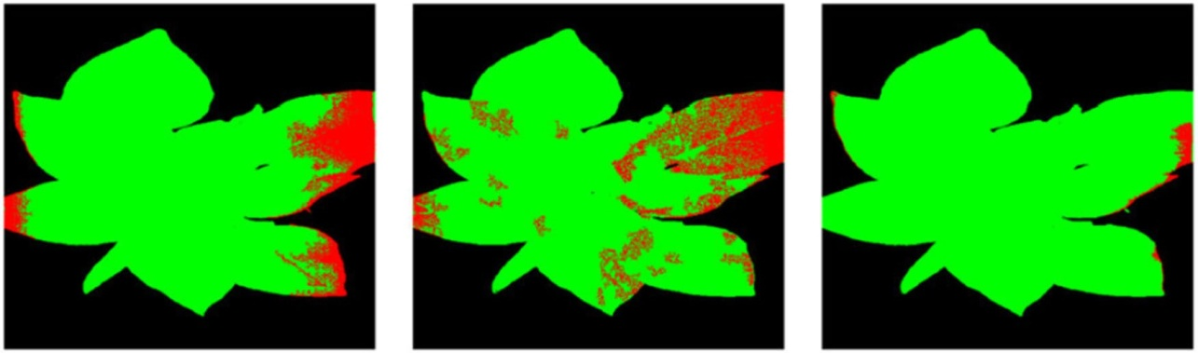

Fig 7. Segmentation comparison(a) DirectCNN (b)AC-GAN (c)OR-AC-GAN

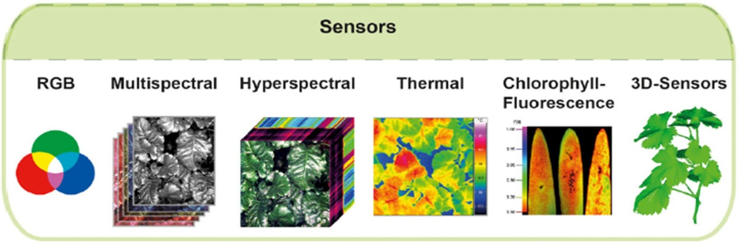

Fig 8. Overview of sensor technologies

FEW-SHOT LEARNING (FSL) WITH IMAGE PROCESSING:

Few-shot learning (FSL) is a machine learning paradigm that enables models to learn from limited labeled datasets. The complexity of the problem and the objective of the experiment influence the number of "shots" required. FSL leverages prior knowledge and datasets during training, optimizing data and models to generate source tasks. FSL is particularly suitable for plant disease detection where datasets are limited in size. Table 13 illustrates various FSL-based techniques for small-sample plant disease detection. Key FSL Techniques:

* Embedding: This involves feature extraction or dimensionality reduction techniques. Pre-trained CNNs (e.g., ImageNet) reduce training time, while SVM with distinct kernels classifies complex systems.
* Multitask Learning: A shared model trains multiple tasks using either hard parameter sharing (HPS) or soft parameter sharing (SPS). In HPS, common parameters are shared across tasks, while SPS trains specific features for individual tasks.

MOLECULAR DIAGNOSIS TECHNIQUES:

Pests and diseases can cause up to 35% losses in global food production. Early detection is crucial to prevent outbreaks of severe plant diseases caused by pathogens such as nematodes, viruses, bacteria, fungi, and oomycetes. Molecular diagnostic techniques bridge the gap between traditional methods and the need for precise disease management. Below are key molecular technologies:

* ELISA (Enzyme-Linked Immunosorbent Assay): Widely used in plant pathology, ELISA detects specific substances in samples via antibody-enzyme interactions, leading to a color change. However, it has limitations in sensitivity and specificity, especially for bacterial pathogens.
* Conventional PCR: This molecular biology technique amplifies DNA sequences using electrophoresis for pathogen detection. While sensitive, it is susceptible to contamination and false positives.
* Real-Time PCR (RT-PCR): A quantitative PCR method offering high sensitivity and specificity for detecting DNA pathogens.

1. **Methodology**
   1. Data Collection - High-quality images of healthy and diseased plant leaves are collected from publicly available datasets, agricultural research organizations, or captured using high-resolution cameras. The dataset is categorized by plant species and disease type.
   2. Data Preprocessing

- Image Resizing: All images are resized to a consistent resolution suitable for the AI model.

- Data Augmentation: Techniques such as rotation, flipping, zooming, and brightness adjustments are applied to increase the diversity of the dataset and prevent overfitting.

- Normalization: Pixel values are scaled to a range of [0, 1] for faster and more accurate model training.

* 1. Feature Extraction - Features such as texture, color, shape, and vein patterns are extracted from the leaf images using computer vision techniques like histogram analysis and edge detection.
  2. Model Selection and Training

- A deep learning model, such as Convolutional Neural Networks (CNNs), is selected for automatic feature extraction and classification.

- The model is trained on the preprocessed dataset using supervised learning techniques. A portion of the data is reserved for validation and testing.

* 1. Performance Optimization

- Hyperparameter Tuning: Learning rate, batch size, and the number of epochs are adjusted to optimize performance.

- Transfer Learning: Pretrained models (e.g., ResNet, VGG) are fine-tuned on the leaf dataset to improve accuracy and reduce training time.

1. Limitations

Automated plant disease detection has made significant progress; however, several limitations persist at various stages of the process. One primary challenge is the difficulty in obtaining samples for specific diseases. The type of dataset used—whether laboratory-controlled or real-time—greatly impacts system performance. Data from uncontrolled environments increases system complexity but is highly relevant for agricultural advancements and modern research. Common classification techniques for plant disease detection include SVM, ANN, Naïve Bayes, backpropagation neural networks, decision trees, and k-nearest neighbors, [30][31]. Convolutional Neural Networks (CNNs) have shown superior performance on large datasets, but overfitting remains a significant issue in deep learning-based systems for plant disease detection. Efforts to enhance the efficiency of CNN-based systems for multi-crop disease detection have been reported in the literature. To address these challenges, proposed systems must meet essential specifications. Overlooking any specification can lead to inaccurate disease detection. Therefore, researchers should design versatile systems with adjustable parameters rather than rigid specifications.

1. Challenges

The literature highlights several challenges in plant disease detection, one of which is the lack of expert annotators capable of accurately differentiating between dead plants and those infected by disease. This task demands skilled professionals, which can be costly and particularly challenging for rare or newly emerging diseases. Additionally, employing deep learning (DL) techniques for modeling, hyperparameter tuning, and training requires substantial resources, posing another significant hurdle. While shallow architectures perform well with smaller datasets, recent advanced models provide new perspectives for building effective plant disease detection systems. Incorporating machine learning (ML), deep learning (DL), and few-shot learning (FSL) is recommended to enhance these models. Future research should focus on improving plant disease detection, classification, and quantification to advance smart agriculture. Key challenges and factors affecting plant disease classification and identification include:

* Feature Extraction and Classification: System performance heavily depends on the techniques used for feature extraction and classification.
* Dataset Dependence: Many studies rely on the Plant Village dataset, which consists of laboratory images, rather than real-time images, significantly impacting classifier performance.
* Real-Time Efficiency: Designing systems that operate efficiently on constrained devices remains a challenge.
* Hyperparameter Tuning: Proper tuning and selection of hyper parameters can significantly impact system performance.

Tentative Solutions

Addressing the challenges in plant disease detection requires innovative and multidisciplinary approaches. For feature extraction and classification, leveraging transfer learning with pre-trained models can significantly reduce the need for extensive manual feature engineering. Additionally, advanced techniques like genetic algorithms or principal component analysis (PCA) can optimize feature selection, enhancing system performance.

The complexity of real-world backgrounds presents another significant obstacle, but robust segmentation algorithms, such as U-Net or Mask R-CNN, can effectively isolate plant regions from complex scenes. Domain adaptation methods can further improve model robustness to background intricacies.

Optimizing pesticide management can be achieved by incorporating spatial analysis and disease severity quantification into detection systems. These advancements can inform decision support systems that combine detection outputs with agronomic data to guide effective pesticide application. Ensuring real-time efficiency remains a critical challenge, especially for deployment on resource-constrained devices. Lightweight models such as MobileNet or EfficientNet, coupled with techniques like model pruning and quantization, can address this issue.

Hyperparameter tuning, a key determinant of model performance, can be streamlined using automated approaches such as Bayesian optimization, grid search, or random search. Cloud-based platforms can also provide scalable solutions for computationally intensive tuning processes.

1. Conclusion

The emergence of plant pathogens poses a significant threat to global food security, ecosystems, and economies. Factors such as globalization, increased mobility, vectors, climate change, and pathogen evolution have accelerated the spread of invasive plant pathogens. To address agricultural losses, the development of automated approaches for plant disease detection and classification is urgently needed. This review explores the use of machine learning (ML), deep learning (DL), and few-shot learning (FSL) for automated plant disease recognition. It highlights key methodologies, including acquisition, preprocessing, segmentation, feature extraction, and classification. While many studies rely on RGB images, some have adopted hyperspectral imaging for plant leaves, which offers the advantage of detecting microscopic symptoms without requiring labeled datasets. These automated techniques have facilitated timely advancements in research. Additionally, the review examines molecular diagnostic tools and state-of-the-art techniques for plant disease detection. The methods discussed are highly sensitive, specific, and capable of rapid detection.

**Societal Benefits of the Project:**

1. Improved Crop Health and Yield - Early detection and accurate classification of plant leaf diseases enable timely intervention, reducing crop losses and ensuring higher yields. This contributes to food security and agricultural sustainability.

2. Empowering Farmers - By providing an accessible and cost-effective tool for disease diagnosis, the project empowers farmers, especially in rural and underdeveloped regions, to take proactive measures without relying solely on agricultural experts.

3. Reduction in Chemical Usage - Accurate disease identification minimizes the overuse or misuse of pesticides and fertilizers, reducing environmental pollution and promoting eco-friendly farming practices.

4. Economic Gains - Preventing large-scale crop damage reduces financial losses for farmers and boosts the agricultural economy. This is especially crucial for small-scale farmers who are more vulnerable to crop failures.

5. Scalable and Efficient Disease Management - AI-driven solutions can process large datasets quickly and provide insights on disease patterns and outbreaks, helping agricultural agencies and policymakers plan better resource allocation and disease management strategies.

References

[1] FAO, IFAD, UNICEF, WFP, WHO, The State of Food Security and Nutrition in the World 2023. Geneva, Switzerland, Jul. 2023.

[2] T. D. March, "State of Agriculture in India," accessed Aug. 9, 2023. [Online]. Available: https://prsindia.org/files/policy/policy_analytical_reports/State%20of%20Agriculture%20in%20India.pdf

[3] C. Janiesch, P. Zschech, and K. Heinrich, "Machine learning and deep learning," Electron. Markets, vol. 31, no. 3, pp. 685–695, Apr. 2021, doi: 10.1007/s12525-021-00475-2.

[4] K. Kc, Z. Yin, D. Li, and Z. Wu, "Impacts of background removal on convolutional neural networks for plant disease classification in-situ," Agriculture, vol. 11, no. 9, p. 827, Aug. 2021, doi: 10.3390/agriculture11090827.

[5] J. Liu and X. Wang, "Plant diseases and pests detection based on deep learning: A review," Plant Methods, vol. 17, no. 1, pp. 1–18, Dec. 2021.

[6] V. K. Vishnoi, K. Kumar, and B. Kumar, ‘‘Plant disease detection using computational intelligence and image processing,’’ J. Plant Diseases Protection, vol. 128, no. 1, pp. 19–53, Aug. 2020, doi: 10.1007/s41348- 020-00368-0.

[7] Evaluations of Brinjal Germplasm for Resistance to Fusarium Wilt Disease. Accessed: Aug. 9, 2023. [Online]. Available: https://www. ijsrp.org/research-paper-0717.php?rp=P676604

[8] P. Adhikari, Y. Oh, and D. Panthee, ‘‘Current status of early blight resistance in tomato: An update,’’ Int. J. Mol. Sci., vol. 18, no. 10, p. 2019, Sep. 2017.

[9] J. Kianat, M. A. Khan, M. Sharif, T. Akram, A. Rehman, and T. Saba, "A joint framework of feature reduction and robust feature selection for cucumber leaf diseases recognition," Optik, vol. 240, Aug. 2021, Art. no. 166566.

[10] M. Agarwal, S. Gupta, and K. K. Biswas, "A new Conv2D model with modified ReLU activation function for identification of disease type and severity in cucumber plant," Sustain. Comput.: Inform. Syst., vol. 30, Jun. 2021, Art. no. 100473.

[11] V. K. Shrivastava, M. K. Pradhan, S. Minz, and M. P. Thakur, "Rice plant disease classification using transfer learning of deep convolution neural network," Int. Arch. Photogramm., Remote Sens. Spatial Inf. Sci., vol. 42, pp. 631–635, Jul. 2019.

[12] J. Chen, D. Zhang, A. Zeb, and Y. A. Nanehkaran, "Identification of rice plant diseases using lightweight attention networks," Exp. Syst. Appl., vol. 169, May 2021, Art. no. 114514.

[13] H. Sun, L. Zhai, F. Teng, Z. Li, and Z. Zhang, "qRgls1.06, a major QTL conferring resistance to gray leaf spot disease in maize," Crop. J., vol. 9, pp. 342–350, Apr. 2021.

[14] A. Abbas, S. Jain, M. Gour, and S. Vankudothu, "Tomato plant disease detection using transfer learning with C-GAN synthetic images," Comput. Electron. Agricult., vol. 187, Aug. 2021, Art. no. 106279.

[15] H. R. Kappali, K. M. Sadyojatha, and S. K. Prashanthi, "Computer vision and machine learning in paddy diseases identification and classification: A review," Indian J. Agricult. Res., vol. 10, pp. 1–5, Mar. 2023. [Online]. Available: https://www.arccjournals.com/journal/indian-journal-of-agricultural-search/A-6061

[16] S. Mustofa, M. M. H. Munna, Y. R. Emon, G. Rabbany, and M. T. Ahad, "A comprehensive review on plant leaf disease detection using deep learning," 2023, arXiv:2308.14087.

[17] A. Bhargava and A. Bansal, "Fruits and vegetables quality evaluation using computer vision: A review," J. King Saud Univ.-Comput. Inf. Sci., vol. 33, no. 3, pp. 243–257, Mar. 2021.

[18] J. G. Arnal Barbedo, "Plant disease identification from individual lesions and spots using deep learning," Biosyst. Eng., vol. 180, pp. 96–107, Apr. 2019.

[19] K. Bashir, M. Rehman, and M. Bari, "Detection and classification of rice diseases: An automated approach using textural features," Mehran Univ. Res. J. Eng. Technol., vol. 38, no. 1, pp. 239–250, Jan. 2019.

[20] J. Parraga-Alava, K. Cusme, A. Loor, and E. Santander, "RoCoLe: A robusta coffee leaf images dataset for evaluation of machine learning-based methods in plant diseases recognition," Data Brief, vol. 25, Aug. 2019, Art. no. 104414, doi: 10.1016/j.dib.2019.104414.

[21] A. N. I. Masazhar and M. M. Kamal, "Digital image processing technique for palm oil leaf disease detection using multiclass SVM classifier," in Proc. IEEE 4th Int. Conf. Smart Instrum., Meas. Appl. (ICSIMA), Nov. 2017, pp. 1–6.

[22]S. Kaur, S. Pandey, and S. Goel, ‘‘Semi-automatic leaf disease detection and classification system for soybean culture,’’ IET Image Process., vol. 12, no. 6, pp. 1038–1048, Jun. 2018

[23]P. Goncharov, G. Ososkov, A. Nechaevskiy, A. Uzhinskiy, andI. Nestsiarenia, ‘‘Disease detection on the plant leaves by deep learning,’’ in Advances in Neural Computation, Machine Learning, and Cognitive Research II. Cham, Switzerland: Springer, 2019, pp. 151–159.

[24]M. Francisco, F. Ribeiro, J. Metrôlho, and R. Dionísio, ‘‘Algorithms and models for automatic detection and classification of diseases and pests in agricultural crops: A systematic review,’’ Appl. Sci., vol. 13, no. 8, p. 4720, Apr. 2023.

[25] M. Bhagat and D. Kumar, "Efficient feature selection using BoWs and SURF method for leaf disease identification," Multimedia Tools and Applications, vol. 82, no. 18, pp. 28187–28211, Feb. 2023, doi: 10.1007/s11042-023-14625-5.

[26] A. S. Deshapande, S. G. Giraddi, K. G. Karibasappa, and S. D. Desai, "Fungal disease detection in maize leaves using Haar wavelet features," in Information and Communication Technology for Intelligent Systems. Singapore: Springer, 2019, pp. 275–286.

[27] S. S. Chouhan, U. P. Singh, and S. Jain, "Applications of computer vision in plant pathology: A survey," Archives of Computational Methods in Engineering, vol. 27, no. 2, pp. 611–632, Apr. 2020.

[28]S. M. Kiran and D. N. Chandrappa, ‘‘Plant disease identification using discrete wavelet transforms and SVM,’’ J. Univ. Shanghai Sci. Technol., vol. 23, no. 6, pp. 108–114, 2021. [Online]. Available: https://jusst. org/wp-content/uploads/2021/06/Plant-Disease-Identification-Using-Discrete-Wavelet-Transforms-and-SVM-1.pdf

[29]R. R. Patil and S. Kumar, ‘‘Rice-fusion: A multimodality data fusion framework for rice disease diagnosis,’’ IEEE Access, vol. 10, pp. 5207–5222, 2022.

[30]D. Zhang, X. Zhou, J. Zhang, Y. Lan, C. Xu, and D. Liang, ‘‘Detection of rice sheath blight using an unmanned aerial system with high-resolution color and multispectral imaging,’’ PLoS ONE, vol. 13, no. 5, May 2018, Art. no. e0187470.

[31]V. K. Shrivastava and M. K. Pradhan, ‘‘Rice plant disease classifi- cation using color features: A machine learning paradigm,’’ J. Plant Pathol., vol. 103, no. 1, pp. 17–26, Oct. 2020, doi: 10.1007/s42161-020- 00683-3.

[32]A. K. Rath and J. K. Meher, ‘‘Disease detection in infected plant leaf by computational method,’’ Arch. Phytopathol. Plant Protection, vol. 52, nos. 19–20, pp. 1348–1358, Dec. 2019.

[33] M. Azadbakht, D. Ashourloo, H. Aghighi, S. Radiom, and A. Alimohammadi, "Wheat leaf rust detection at canopy scale under different LAI levels using machine learning techniques," Comput. Electron. Agricult., vol. 156, pp. 119–128, Jan. 2019.

[34]B. S. Kusumo, A. Heryana, O. Mahendra, and H. F. Pardede, ‘‘Machine learning-based for automatic detection of corn-plant diseases using image processing,’’ in Proc. Int. Conf. Comput., Control, Informat. Appl. (IC3INA), Nov. 2018, pp. 93–97.

[35]A. Kaya, A. S. Keceli, C. Catal, H. Y. Yalic, H. Temucin, andB. Tekinerdogan, ‘‘Analysis of transfer learning for deep neural network based plant classification models,’’ Comput. Electron. Agricult., vol. 158, pp. 20–29, Mar. 2019.

[36]L. Hallau, M. Neumann, B. Klatt, B. Kleinhenz, T. Klein, C. Kuhn,M. Röhrig, C. Bauckhage, K. Kersting, A. Mahlein, U. Steiner, andE. Oerke, ‘‘Automated identification of sugar beet diseases using smart- phones,’’ Plant Pathol., vol. 67, no. 2, pp. 399–410, Feb. 2018.

[37] J. D. Pujari, R. Yakkundimath, and A. S. Byadgi, "SVM and ANN based classification of plant diseases using feature reduction technique," Int. J. Interact. Multimedia Artif. Intell., vol. 3, no. 7, p. 6, 2016.

[38] R. D. L. Pires, D. N. Gonçalves, J. P. M. Oruě, W. E. S. Kanashiro,J. F. Rodrigues, B. B. Machado, and W. N. Gonçalves, ‘‘Local descriptors for soybean disease recognition,’’ Comput. Electron. Agricult., vol. 125, pp. 48–55, Jul. 2016.

[39] S. Sladojevic, M. Arsenovic, A. Anderla, D. Culibrk, and D. Stefanovic, ‘‘Deep neural networks based recognition of plant diseases by leaf image classification,’’ Comput. Intell. Neurosci., vol. 2016, pp. 1–11, May 2016.

[40] P. Jolly and S. Raman, ‘‘Analyzing surface defects in apples using Gabor features,’’ in Proc. 12th Int. Conf. Signal-Image Technol. Internet-Based Syst. (SITIS), Nov. 2016, pp. 178–185.

[41] M. Sharif et al., "Detection and classification of citrus diseases in agriculture based on optimized weighted segmentation and feature selection," Computers and Electronics in Agriculture, vol. 150, pp. 220–234, Jul. 2018.

[42] N. Sengar, M. K. Dutta, and C. M. Travieso, ‘‘Computer vision based technique for identification and quantification of powdery mildew dis- ease in cherry leaves,’’ Computing, vol. 100, no. 11, pp. 1189–1201, Nov. 2018.

[43] S. M. Javidan, A. Banakar, K. A. Vakilian, and Y. Ampatzidis, ‘‘Diagnosis of grape leaf diseases using automatic K-means clustering and machine learning,’’ Smart Agricult. Technol., vol. 3, Feb. 2023, Art. no. 100081, doi: 10.1016/j.atech.2022.100081.

[44] S. Zhang, Y. Zhu, Z. You, and X. Wu, "Fusion of superpixel, expectation maximization, and PHOG for recognizing cucumber diseases," Computers and Electronics in Agriculture, vol. 140, pp. 338–347, Aug. 2017.

[45] A. Bhatia, A. Chug, and A. P. Singh, ‘‘Hybrid SVM-LR classifier for powdery mildew disease prediction in tomato plant,’’ in Proc. 7th Int. Conf. Signal Process. Integr. Netw., Feb. 2020, pp. 218–223. [Online].Available: <https://ieeexplore.ieee.org/document/9071202>

[46] G. Geetharamani and A. Pandian, ‘‘Identification of plant leaf diseases using a nine-layer deep convolutional neural network,’’ Comput. Electr. Eng., vol. 76, pp. 323–338, Jun. 2019

[47] M. Mehdipour Ghazi, B. Yanikoglu, and E. Aptoula, ‘‘Plant identification using deep neural networks via optimization of transfer learning parame- ters,’’ Neurocomputing, vol. 235, pp. 228–235, Apr. 2017.

[48] B. Liu, Y. Zhang, D. He, and Y. Li, ‘‘Identification of apple leaf diseases based on deep convolutional neural networks,’’ Symmetry, vol. 10, no. 1, p. 11, Dec. 2017.

[49] R. Chen, H. Qi, Y. Liang, and M. Yang, ‘‘Identification of plant leaf dis- eases by deep learning based on channel attention and channel pruning,’’ Frontiers Plant Sci., vol. 13, Nov. 2022.

[50] H. Nazki, S. Yoon, A. Fuentes, and D. S. Park, ‘‘Unsupervised image translation using adversarial networks for improved plant disease recog- nition,’’ Comput. Electron. Agricult., vol. 168, Jan. 2020, Art. no. 105117.

[51] Y. Tian, G. Yang, Z. Wang, E. Li, and Z. Liang, ‘‘Detection of apple lesions in orchards based on deep learning methods of CycleGAN and YOLOV3-dense,’’ J. Sensors, vol. 2019, pp. 1–13, Apr. 2019.

[52] Q. Wu, Y. Chen, and J. Meng, ‘‘DCGAN-based data augmenta- tion for tomato leaf disease identification,’’ IEEE Access, vol. 8, pp. 98716–98728, 2020.

[53] B. Liu, C. Tan, S. Li, J. He, and H. Wang, ‘‘A data augmentation method based on generative adversarial networks for grape leaf disease identifi- cation,’’ IEEE Access, vol. 8, pp. 102188–102198, 2020.

[54] Z. Lin, S. Mu, A. Shi, C. Pang, and X. Sun, ‘‘A novel method of maize leaf disease image identification based on a multichannel convolutional neural network,’’ Trans. ASABE, vol. 61, no. 5, pp. 1461–1474, 2018.

[55] J. G. Arnal Barbedo, "Plant disease identification from individual lesions and spots using deep learning," Biosyst. Eng., vol. 180, pp. 96–107, Apr. 2019.

[56] A. G. Howard, M. Zhu, B. Chen, D. Kalenichenko, W. Wang, T. Weyand,M. Andreetto, and H. Adam, ‘‘MobileNets: Efficient convolutional neural networks for mobile vision applications,’’ 2017, arXiv:1704.04861.

[57] Lv, W., & Wang, X. (2020). Overview of hyperspectral image classification. Journal of Sensors, 2020, 1–13. https://doi.org/10.1155/2020/4817234